GAME SALES ANALYSIS

Brief idea about the final data:
Product Performance (Sales): The core business metric is captured by the regional sales figures (NA_Sales, EU_Sales, JP_Sales) and the crucial combined figure, Global_Sales. This allows you to identify top-selling products, key geographic markets, and potential revenue opportunities.
- Product Attributes: Columns like Name, Platform, Year, Genre, and Publisher help categorize the products and analyze which combinations lead to the greatest success (e.g., "Which genres sell best on which platforms?").
- User Engagement & Demand: The data includes powerful indicators of customer interest and perceived quality, such as Rating, Number_of_Reviews, Plays, Backlogs, and Wishlist. These metrics show user sentiment and future demand, which are essential for marketing and investment decisions.
In short, this dataset lets a business track historical commercial success and user passion to drive future strategic decisions regarding game development, platform priority, and market focus.

OBJECTIVES:

- Identify Top-Tier Revenue Drivers: Determine the top-performing games, most successful genres, and leading publishers by total Global Sales to establish clear market leaders for strategic focus.
- Analyze Regional Market Disparities: Compare and contrast the sales distribution across key regions (NA_Sales, EU_Sales, JP_Sales) to identify the primary market and tailor regional marketing or development strategies.
- Evaluate Platform Profitability: Assess the commercial viability of various gaming Platforms by aggregating sales and engagement metrics to guide future resource allocation and platform-specific development decisions.
- Determine the Impact of User Sentiment: Analyze the correlation between user engagement metrics (Rating, Backlogs, Wishlist, Reviews) and commercial success (Global_Sales) to understand how perceived quality and demand drive revenue.
- Formulate Strategic Recommendations: Deliver actionable insights and data-backed recommendations for game development, marketing, and publishing strategies aimed at maximizing future sales and market share.

RESEARCH METHODLOGIES

- The analysis utilized two primary, independent datasets:
- Game Data: Contained core product attributes (e.g., Name, Platform, Year, Genre, Publisher).
- Sales Data: Contained regional and global sales metrics (e.g., NA_Sales, EU_Sales, Global_Sales).
2. Data Cleaning and Pre-processing (Python)

To ensure data quality and readiness for integration, the two datasets were independently processed using Python. This phase included:
- Cleaning: Addressing missing values, handling data type inconsistencies, and correcting any structural errors within each dataset.
- Transformation: Standardizing column names and formats to prepare for the subsequent merging phase.
3. Data Integration (SQL)

The cleaned datasets were joined into a unified analytical structure using SQL (Structured Query Language) joins.
- Process: An appropriate join operation (likely an INNER JOIN or LEFT JOIN) was executed on a common key field (e.g., Game Name/ID) to create a single, comprehensive table linking game attributes with their corresponding sales performance.
- Outcome: The integrated dataset provided a holistic view of product characteristics and commercial success.
4. Data Analysis and Visualization (Tableau)

The final, integrated dataset was loaded into Tableau to facilitate exploratory analysis and visual communication of findings.
- Analysis: Key business questions were addressed by creating calculated fields, aggregating data (e.g., total sales by genre, average sales by platform), and identifying top-performing entities.
- Visualization: Various interactive charts, graphs, and dashboards were developed to clearly illustrate market trends, regional sales distribution, and the correlation between game attributes and commercial performance.

Python for data processing:
I. Data Cleaning and Processing of 'games' data (Game Details)
This script focuses on making the game details (ratings, reviews, teams, summaries) structured and complete:
Code Step | Simple Explanation for Project Purpose
Loading & Structural Cleaning | The code loads the raw data, deletes unnecessary technical columns (like 'Unnamed: 0'), and removes any duplicated rows to ensure every game entry is unique.
Convert Metrics ('K' Handling) | It converts large numbers in metrics like 'Times Listed' and 'Plays' (which might be written as '10K') from text into actual integer numbers, making them usable for calculations and Tableau measures.
Date Standardization | It converts the 'Release Date' column into a standard date format and fills in any missing dates with the most common (median) date to keep the timeline analysis complete.
Fixing Blanks (Text Data) | It replaces all empty or unreadable values in key text fields like 'Team' and 'Genres' with the word "Unknown" so these records are not lost in the analysis.
Text Sanitation for SQL | It cleans up the 'Summary' and 'Reviews' text by removing line breaks and special characters (like changing " to ') to prevent errors when importing the data into the SQL database.
Filling Remaining Nulls | It ensures the 'Rating' column is complete by filling any missing values with the average rating, and ensures the 'Title' column is complete by filling blanks with "Unknown Title."
Rename & Export | Finally, it removes spaces from all column names (e.g., changes 'Global Sales' to 'Global_Sales') for easy use in SQL and exports the clean data to a new CSV file.

II. Data Cleaning and Processing of 'vgsales' data (Sales Data)
This script focuses on making the sales data accurate and standardized:
Code Step | Simple Explanation for Project Purpose
Remove Duplicates | Ensures every sales record is unique.
Filling Gaps | Fills missing Year values with the average year and missing Publisher names with "Unknown" to keep the data whole for timelines and category analysis.
Type Integrity | Ensures all regional and global sales columns contain valid decimal numbers (floats), replacing any non-number entries with zero so they can be summed and averaged correctly.
Standardize Column Names | Removes spaces from all column names (e.g., 'NA Sales' becomes 'NA_Sales') to match the naming convention of the Game Details dataset for the upcoming SQL join.
Export | Saves the cleaned sales data to a new CSV file.

SQL for joining the datasets (LEFT JOIN)
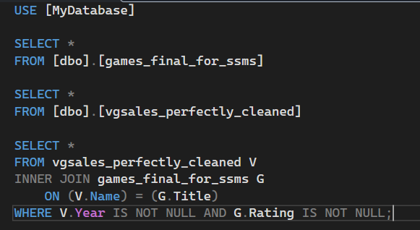
The above SQL query is used for:
- Connecting Two Lists: It takes a list of games from a Sales Data table and matches them with games from a Game Details table.
- Matching Games: The match is made by comparing the game's name from the sales list with the game's title from the details list, ignoring differences in capitalization and extra spaces to ensure accuracy.
- Filtering for Quality: It only keeps games that have a valid release Year (from the sales list) AND a valid Rating (from the details list) i.e which are NOT NULL.
Tableau Dashboards:
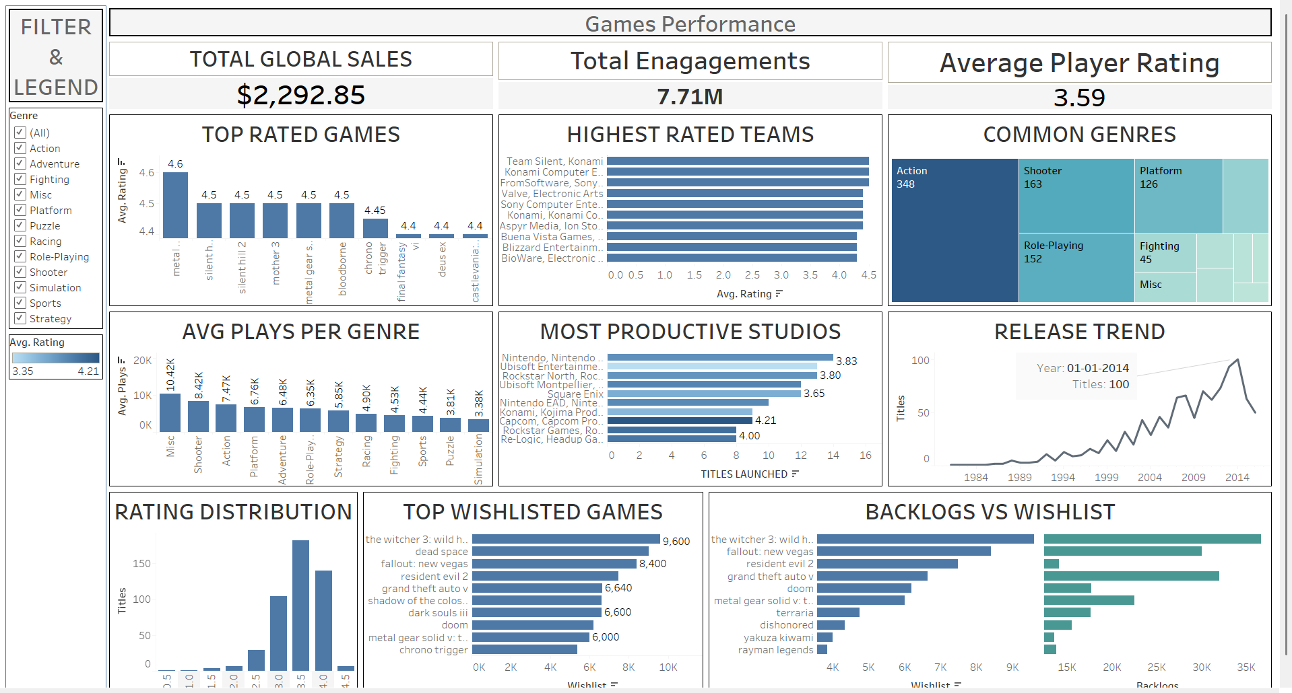
- Total Global Sales, Engagements, & Avg Rating (KPIs): These provide a snapshot of the portfolio's health, showing a total engagement of 7.71M and a steady player rating of 3.59.
  - Action: Establish these as baseline benchmarks for all new title launches.
- Top Rated Games & Highest Rated Teams: Identifies critical successes like Metal Gear and high-performing development groups.
  - Action: Conduct post-mortems on these "hero" titles to replicate their design philosophy in future projects.
- Common Genres (Tree map) vs. Avg Plays Per Genre: Shows that Action is the most common genre (348 titles), but Misc and Shooter genres actually drive higher average engagement.
  - Action: Consider diversifying the portfolio into the "Shooter" genre, which shows higher player engagement despite having fewer titles than "Action."
- Most Productive Studios: Compares the number of titles launched against their average ratings.
  - Action: Reallocate budget toward studios that maintain high ratings (e.g., those with a 4.0+ rating) even if their output volume is lower.
- Top Wishlisted Games & Backlogs vs. Wishlist: Highlights massive future demand for titles like The Witcher 3: Wild Hunt (9,600 wishlists) while tracking games that players haven't finished (Backlogs).
  - Action: Use "Backlog" data to identify if certain games are too long or difficult; use high "Wishlist" numbers to prioritize marketing spend for sequels or DLC.
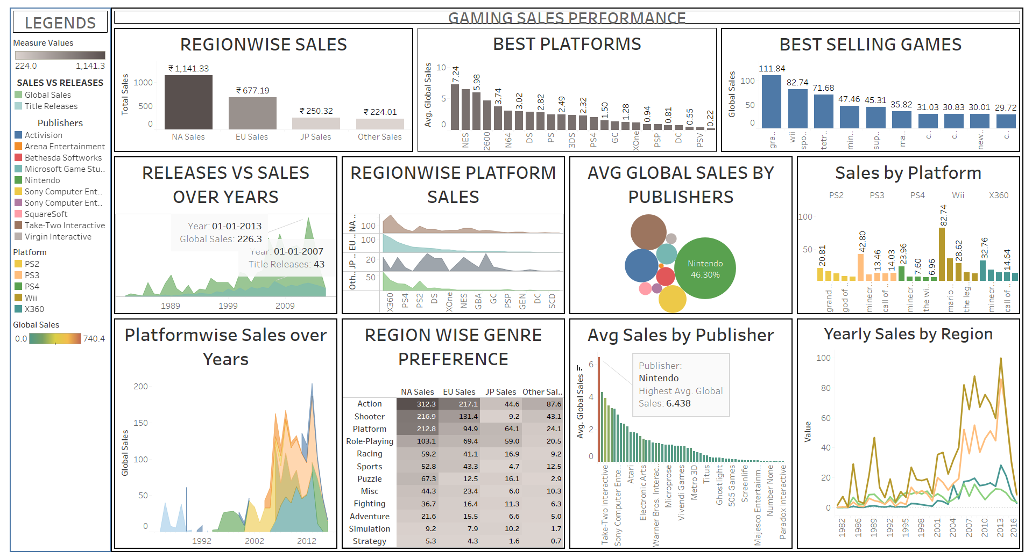
1. Market & Platform Dominance (Top Row)
- Regionwise Sales (Bar Chart): Shows a heavy reliance on North American (NA) sales ($1,141.33), which are nearly double that of the next largest market, the EU.
  - Action: Conduct a "Gap Analysis" on JP and "Other Sales" markets. If global expansion is a goal, these regions represent significant untapped potential compared to the saturated NA market.
- Best Platforms (Bar Chart): Ranks platforms by average global sales, with the NES leading significantly.
  - Action: For a publisher, this suggests that "Legacy" or "Retro" titles have extremely high per-unit value. Consider remastering top-performing classic titles for modern consoles.
- Best Selling Games (Bar Chart): Highlights the top individual revenue generators (e.g., Grand Theft Auto, Wii Sports).
  - Action: Analyze the common attributes of these "megahits." Is it the open-world nature or the bundled hardware (like Wii Sports)? Use these insights to greenlight future AAA projects.
2. Temporal & Trend Analysis (Left & Bottom-Left)
- Releases vs. Sales Over Years (Area Chart): Compares the volume of titles released against actual global sales revenue.
  - Action: Look for "efficiency years" where sales were high despite fewer releases. This indicates a "Quality over Quantity" strategy is more profitable than flooding the market.
- Platformwise Sales Over Years (Stacked Area Chart): Shows the rise and fall of different console lifecycles (PS2, PS3, PS4, Wii, X360).
  - Action: Use this to time the "Sunset Phase" for older platforms. When the sales area for a console like PS3 begins to thin, shift development resources entirely to the next generation (PS4/PS5).
3. Publisher & Genre Strategy (Center & Right)
- Avg Global Sales by Publishers (Bubble Chart): Uses size and color to show market share, with Nintendo dominating at $46.30\%$.
  - Action: For competitors, this is a signal to differentiate. Don't compete head-to-head with Nintendo's family-friendly niche; instead, pivot to genres where they are less dominant, like "Shooter" or "Action."
- Region Wise Genre Preference (Heatmap/Table): Provides a clear view of what sells where. For example, Action is a powerhouse in NA ($312.3$), while Role-Playing is much more competitive in JP ($59.0$).
  - Action: Regionalize your marketing and development. If launching a new Role-Playing game, prioritize the JP market for early release and localized content.
- Avg Sales by Publisher (Ranked Bar Chart): Specifically calls out Nintendo as having the highest average global sales ($6.438$).
  - Action: Study Nintendo's "First-Party" strategy. High average sales per title usually indicate strong brand loyalty and high-quality control.
4. Granular Sales Tracking (Right Column)
- Sales by Platform (Detailed Bar Chart): Drills down into specific hit titles for consoles like Wii ($82.74$ for Mario) and PS3 ($42.80$ for Grand Theft Auto).
  - Action: Identify "Platform Sellers"—games that drive hardware sales. Form strategic partnerships with these developers to ensure platform exclusivity.
- Yearly Sales by Region (Multi-Line Chart): Tracks the volatility of different regions over time.
  - Action: Identify periods of "Market Shock" (dips in the line). Investigate if these were caused by economic recessions or lack of major hardware releases to better forecast future downturns.
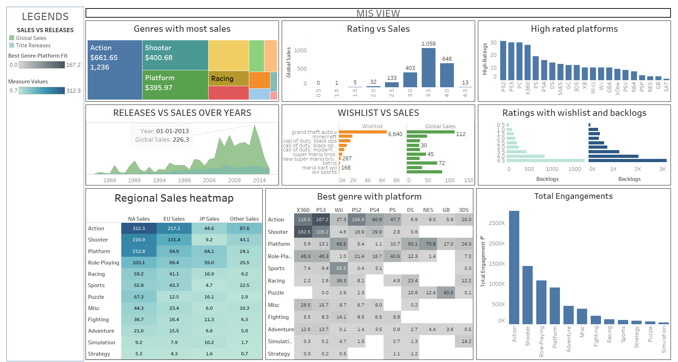
1. Market Composition & Financial Health
- Genres with most sales (Tree map): This chart visualizes market dominance, showing Action ($661.65M) and Shooter ($400.68M) as the primary revenue drivers.
  - Business Action: Allocate a higher percentage of the R&D budget toward Action and Shooter titles to maintain market share.
- Rating vs. Sales (Histogram/Bar): This reveals a "Sweet Spot" for revenue; games rated between 3.5 and 4.0 generate the highest sales ($1,058M), significantly outperforming those with lower ratings.
  - Business Action: Implement a "Quality Gate" in development; titles projected to score below 3.5 should be delayed for further refinement to avoid the steep revenue drop-off.
2. Quality & Platform Benchmarking
- High rated platforms (Bar Chart): Ranks platforms by their ability to host high-quality games, with PS2, PS3, and PC leading the pack.
  - Business Action: Prioritize these "high-trust" platforms for premium releases or exclusives to maximize critical reception.
- Best genre with platform (Heatmap): Maps the intersection of genre and hardware, showing, for example, high density for Shooters on X360 and Action on PS3.
  - Business Action: Direct marketing spends toward platform-genre pairs that historically yield high sales (e.g., target X360 audiences specifically for new Shooter IPs).

3. Predictive Intent & Retention Analysis
- Wishlist vs. Sales (Comparison Bar): Correlates pre-launch hype (Wishlist) with actual Global Sales for titles like GTA V and Call of Duty.
  - Business Action: Use "Wishlist Velocity" as a leading indicator to adjust production volume for physical copies and server capacity for digital launches.
- Ratings with wish-list and backlogs (Diverging Bar): Tracks how quality impacts player retention and the accumulation of unfinished games (backlogs).
  - Business Action: For titles with high backlogs, analyse gameplay "churn points" to improve retention in sequels or via title updates.

4. Player Engagement Trends
- Total Engagements (Bar Chart): Confirms that Action and Shooter genres not only sell the most but also have the highest active player volumes.
  - Business Action: Focus "Live-Service" models (season passes, DLC) on these two genres to capitalize on the sustained engagement of their massive player bases.
- Releases vs. Sales Over Years (Area Chart): Provides a historical view of industry growth and efficiency.
  - Business Action: Analyse the years with the highest "Revenue-per-Release" to identify optimal windowing strategies for future launch cycles.

IMPLICATIONS:
- Portfolio Diversification into High-Engagement Genres: While "Action" titles have the highest volume, management should shift R&D focus toward the Shooter genre. Data shows shooters drive higher average player engagement and represent a primary revenue driver ($400.68M) alongside action.
- Implementation of a "Quality Gate" for Development: To maximize revenue, titles should aim for the "sweet spot" rating of 3.5 to 4.0, which historically generates the highest sales ($1,058M). Projects projected to score below 3.5 should be delayed for refinement to avoid the steep revenue drop-off observed with lower-rated games.
- Targeted Regional Product Alignment: Marketing and development resources should be localized based on regional preferences. For example, management should prioritize the Japanese (JP) market for Role-Playing Game (RPG) launches, as this genre is significantly more competitive and preferred in that region.
- Infrastructure and Inventory Optimization via "Wishlist Velocity": Management should use pre-launch Wishlist numbers as a leading indicator to forecast demand. This data allows for more accurate adjustments of physical copy production volumes and digital server capacity for major launches like Grand Theft Auto V.
- Retention and Lifecycle Management through Backlog Analysis: High "Backlog" metrics should trigger an investigation into gameplay "churn points". By analyzing why players are not finishing specific titles, managers can improve retention strategies for future sequels or provide corrective updates for current titles.
- Strategic Differentiation from Market Leaders: Given Nintendo’s massive 46.30% market share and brand loyalty, competitors should avoid head-to-head competition in their "family-friendly" niche. Instead, managers should pivot to genres where Nintendo is less dominant, such as "Shooter" or "Action".

